**Blue Teaming: Getting Paid to Defend Stuff (and Stress About Logs)**

**Meta:** Think you’re too calm for red teaming? Prefer catching bad guys instead of being one? Enjoy SIEM dashboards, logs, alerts, and existential dread? Welcome to blue teaming.

Photo by [Eyasu Etsub](https://unsplash.com/@jphotography2012?utm_source=medium&utm_medium=referral) on [Unsplash](https://unsplash.com/?utm_source=medium&utm_medium=referral" \t "_blank)

**1. What Is Blue Teaming?**

Blue teaming is like being the dungeon master of cybersecurity. You don’t attack systems, rather you protect them. You’re the person who sees a weird login from Russia at 3 AM and screams internally. You’re the firewall. The defender. The nerd with 30 tabs open and coffee in both hands (or tea).

If red teaming is the offense, blue teaming is the defense. And trust me, it’s not just pushing buttons on antivirus software, it’s full-blown cyber detective work, minus the cool trench coat.



Detective Rat. Credit: GIPHY

**2. How It Works (Without Crying… Much… It’s Just the Basics)**



Detect… Detect… Detect…

* You monitor systems.
* You detect anomalies.
* You investigate incidents.
* You mitigate threats.
* You write reports. (Yes, again. Sorry.)

And then you do it all over again, because attackers don’t take weekends off.

**3. Blue Team Tools of the Trade**

Blue Team Tools. Credit: GPT and I

You don’t need every tool, but you do need to actually understand what the logs are screaming at you.

**4. A Day in the Life of a Blue Teamer**



Timetable? Credit: GIPHY

**Step 1: Wake Up to PagerDuty Alerts**

Usually something like: “High CPU Usage Detected on Production Server” at 4:12 AM. Ah… Classic.

**Step 2: Triage Madness**

Is it a threat? A false positive? A misconfigured script written by DarKVoicE from DevOps? Who knows.

**Step 3: Log Diving**

SIEM says there’s suspicious lateral movement. Time to sift (examine) through 6GB of logs, each less helpful than the last.

**Step 4: Contain and Remediate**

Quarantine host, kill processes, update IOCs, notify stakeholders, reheat coffee.

**Step 5: Write the Report**

Because if it’s not documented, it never happened. Also, compliance teams are terrifying.

**Step 6: Threat Hunt for Fun(?)**

Proactively look for threats across endpoints. Basically: “*Where’s Waldo: Cyber Edition.*”

**5. What Blue Teamers Defend Against**

What to defend against?

Being a blue teamer is like being a lifeguard during a shark convention.



Pat the Shark? Credit: GIPHY

**6. Blue Team Mindset: Trust Nothing, Verify Everything**

* **Paranoia = Productivity:** Always assume something’s broken or compromised.
* **Alert Fatigue is Real:** But you still read every single one.
* **Logs Are Sacred:** If it’s not logged, it didn’t happen.
* **Detection > Reaction:** The faster you spot it, the less you panic.



Detect 24/7. Credit: GIPHY

**7. How to Get Started in Blue Teaming (My Personal Recommendations)**

**Practice on:**

* BlueTeamLabs, CyberDefenders, RangeForce
* TryHackMe Blue team paths
* Build your own home lab with Security Onion, ELK stack, and Sysmon chaos.

**Learn:**

* How operating systems actually work.
* What logs look like when things go horribly wrong.
* MITRE ATT&CK framework like it’s your second language.

**Read:**

* SANS Blue Team Handbook
* “Practical Packet Analysis” by Chris Sanders
* Threat hunting reports from Mandiant, CrowdStrike, and friends

**Watch:**

* John Hammond, TCM Security, HuskyHacks on YouTube
* DEFCON & Blue Team Village talks

**8. Things Not to Do as a Blue Teamer**

* Assume everything’s fine
* Ignore alerts “just this once”
* Blame the intern (unless it really was the intern)
* Forget to patch
* Give users admin rights. Ever.

**9. Where Do Blue Teamers Work?**



Photo by [Jakub Żerdzicki](https://unsplash.com/@jakubzerdzicki?utm_source=medium&utm_medium=referral) on [Unsplash](https://unsplash.com/?utm_source=medium&utm_medium=referral" \t "_blank)

* SOCs (Security Operations Centers)
* Financial institutions
* Government agencies
* Enterprises with too much to lose
* MSPs and MSSPs

If someone has valuable data and a pulse, they need a blue team.

**10. Blue Team Roles & Paychecks (Some places you won't get a penny but here is the general statistics)**

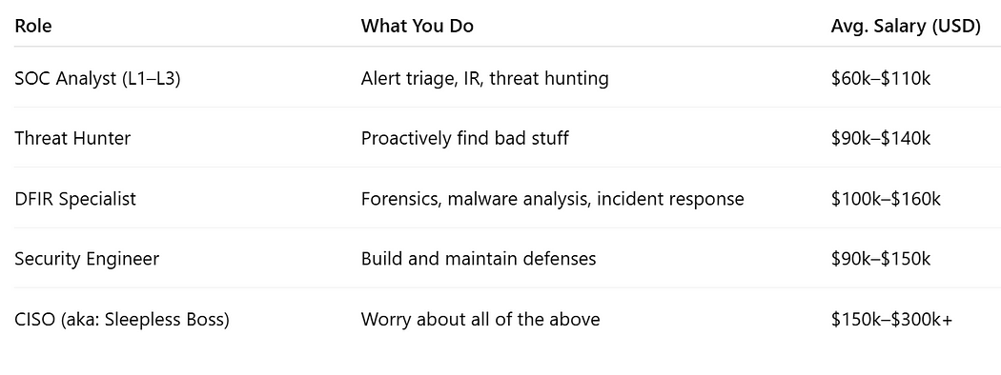

paychecks we dream of. Credit: Him and I

**TLDR (Blue but Brief)**

* Blue teaming = Cyber defense + logs + paranoia + caffeine.
* You’re not smashing firewalls, you’re quietly saving the day while fighting alert fatigue.
* If you like hunting threats, writing detection rules, and yelling at logs, this is your vibe.

***Quiz Time***

1. **What’s the first thing you do when you see an alert?**

a) Ignore it  
b) Investigate context and source  
c) Reboot the server  
d) Cry

**2. What’s the best way to detect lateral movement?**

a) Telepathy  
b) SIEM log correlation  
c) Brute force guessing  
d) Ask the red team nicely

**3. What should you do after handling an incident?**

a) Sleep  
b) Postmortem and lessons learned  
c) Burn everything  
d) Blame HR

*(Answers: 1b, 2b, 3b — obviously)*

**Enjoyed the read?**  
Smash the follow button, drop a comment, and share this with someone who still thinks “password” is a good password.